NAME: VHUHWAVHO

SURNAME: RASILA

STUDENT NO: ST10497221

MODULE CODE: WEDE5020

QUALIFICATION: DIPLOMA IN NETWORK MANAGEMENT  
  
  
  
GITHUB REPOSITORY

<https://github.com/Vhuhwavho-Rasila/DEVINE_POE_ST10497221>  
  
GITHUB WEBISTE URL  
[**https://vhuhwavho-rasila.github.io/DEVINE_POE_ST10497221/**](https://vhuhwavho-rasila.github.io/DEVINE_POE_ST10497221/)  
  
Overview

DEVINE DINE was born from a passion for exceptional cuisine and the rich culinary heritage of South Africa. Founded in 2010 by award-winning chef Vhuhwavho Rasila, our restaurant brings a modern twist to traditional South African flavours.

Located in the heart of Cape Town, DEVINE DINE offers an intimate dining experience where every dish tells a story. Our menu celebrates the diversity of South African ingredients, sourced locally from trusted farmers and producers.

Our elegant atmosphere, impeccable service, and innovative cuisine have earned us recognition as one of South Africa's premier fine dining destinations.

Pages

1. Home(index.html)
2. About(about.html)
3. Menu(menu.html)
4. Reservations(reservation.html)
5. Contact(contact.html)

Home (Index.html)

* This page contains the logo, navigations(hyperlinks) to other pages of the website. It also has the restaurant and food pictures. it has the Devine restaurant maps and also a reservation form to book prior. It also contains the s

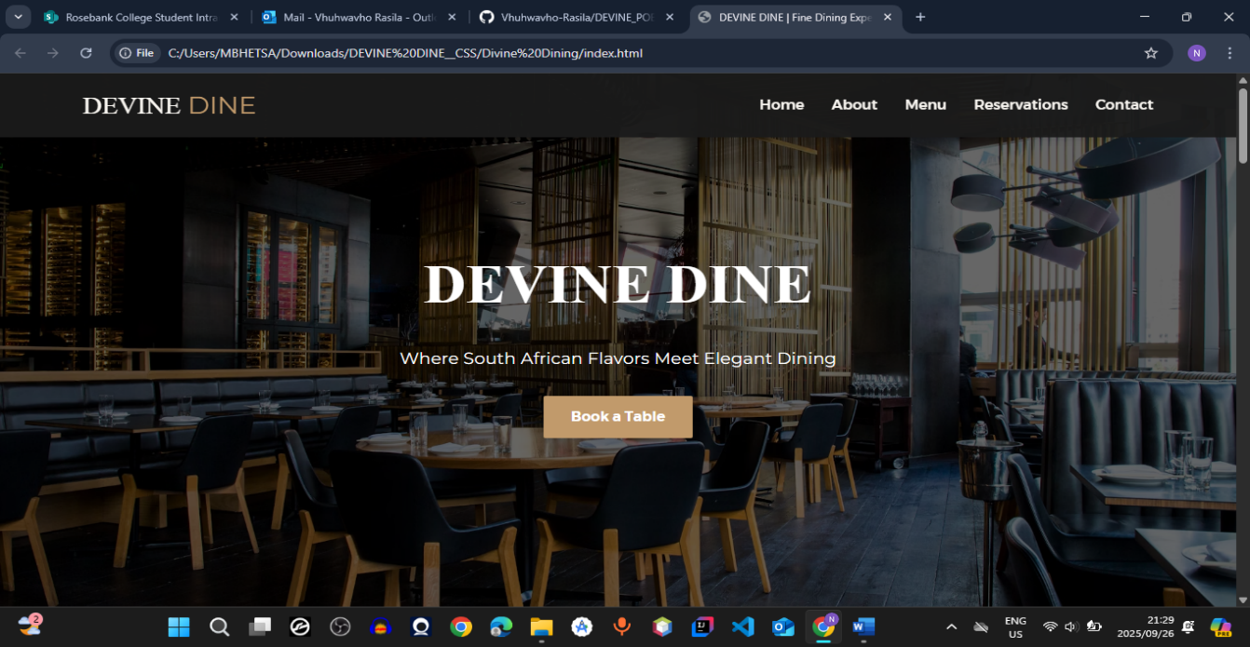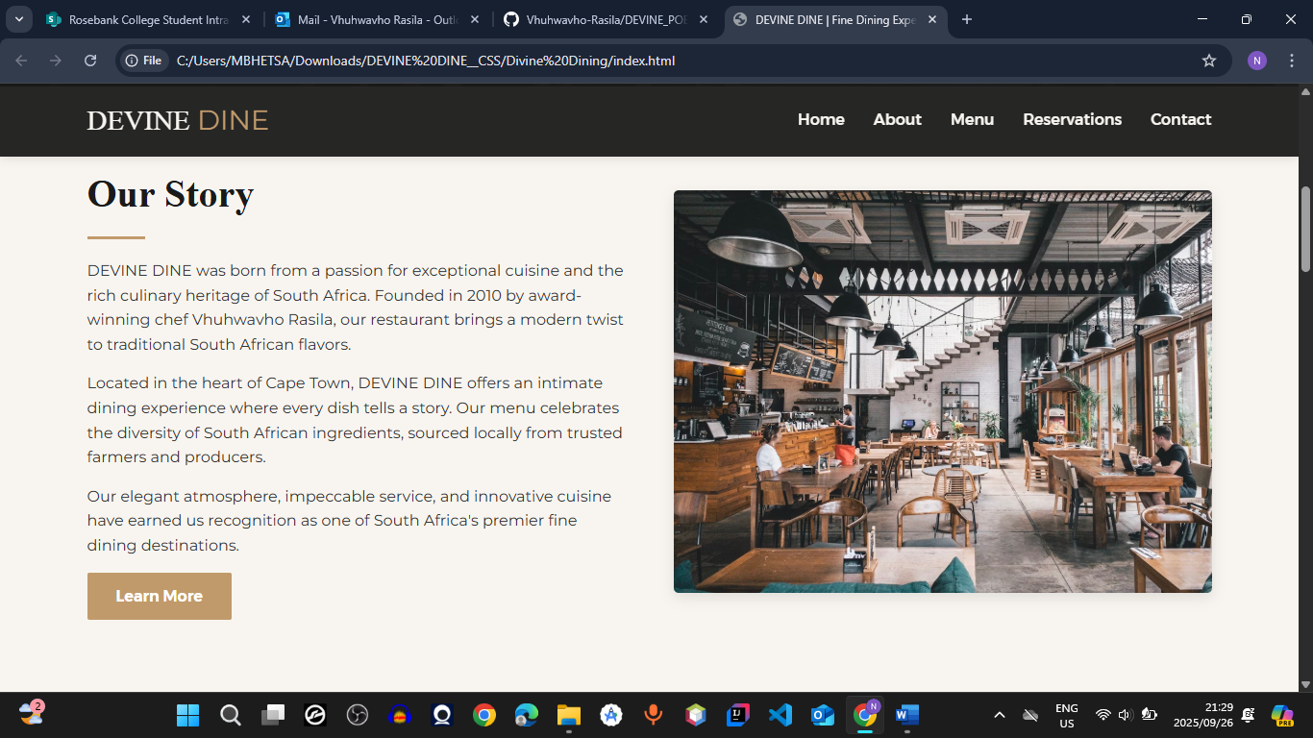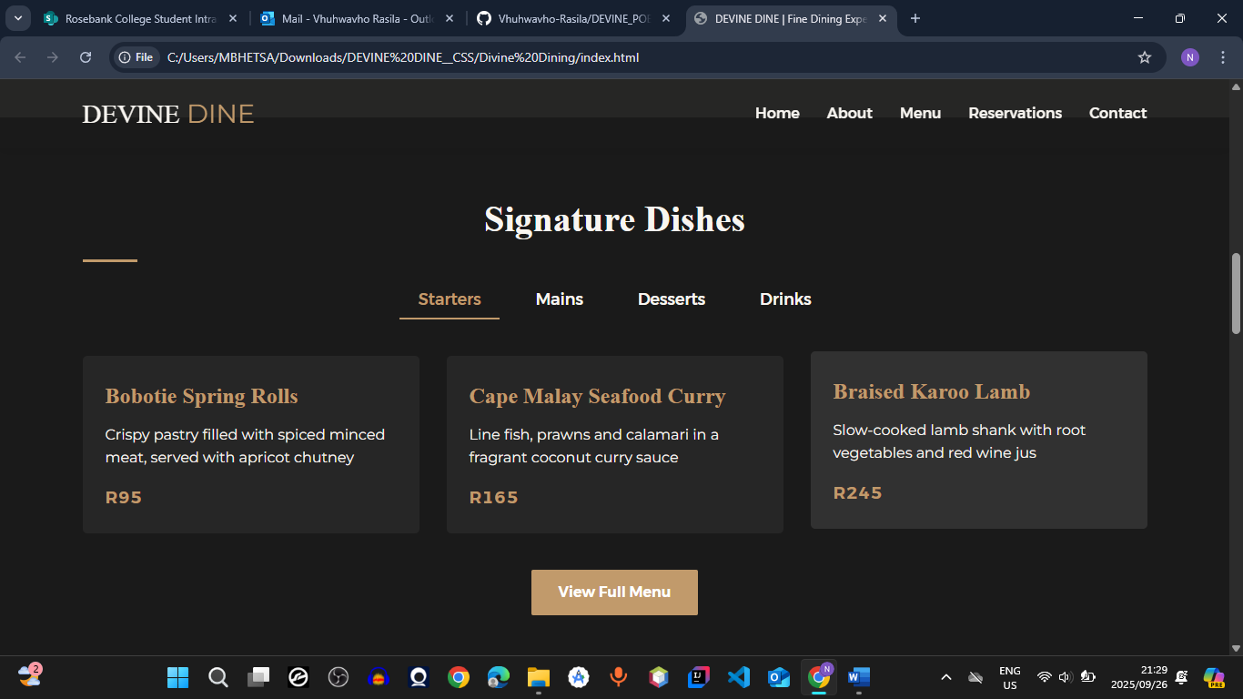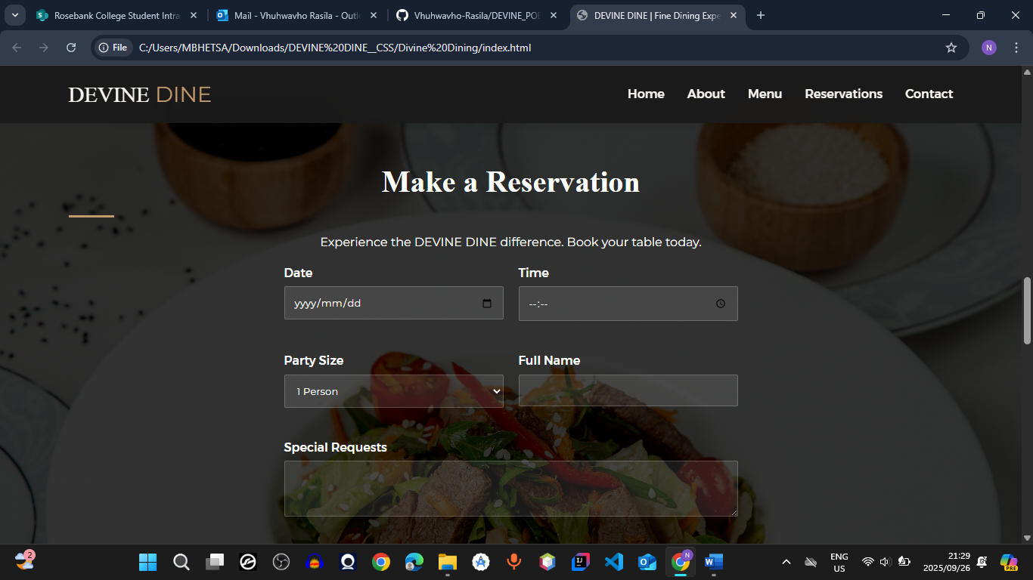

About (about.html)

* This page contains the logo, navigations(hyperlinks) to other pages of the website. It also has information of the restaurant, the manager, and staff

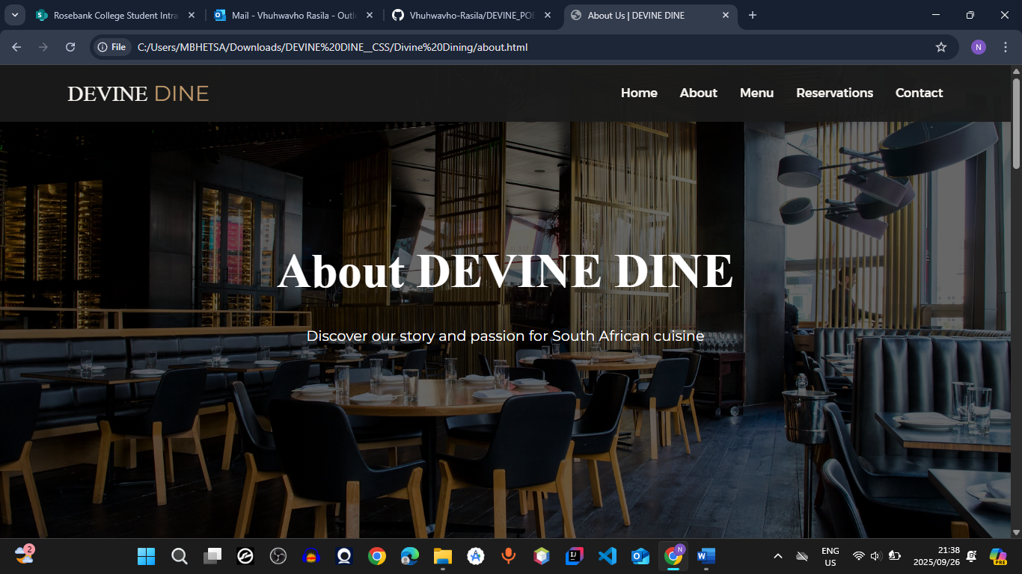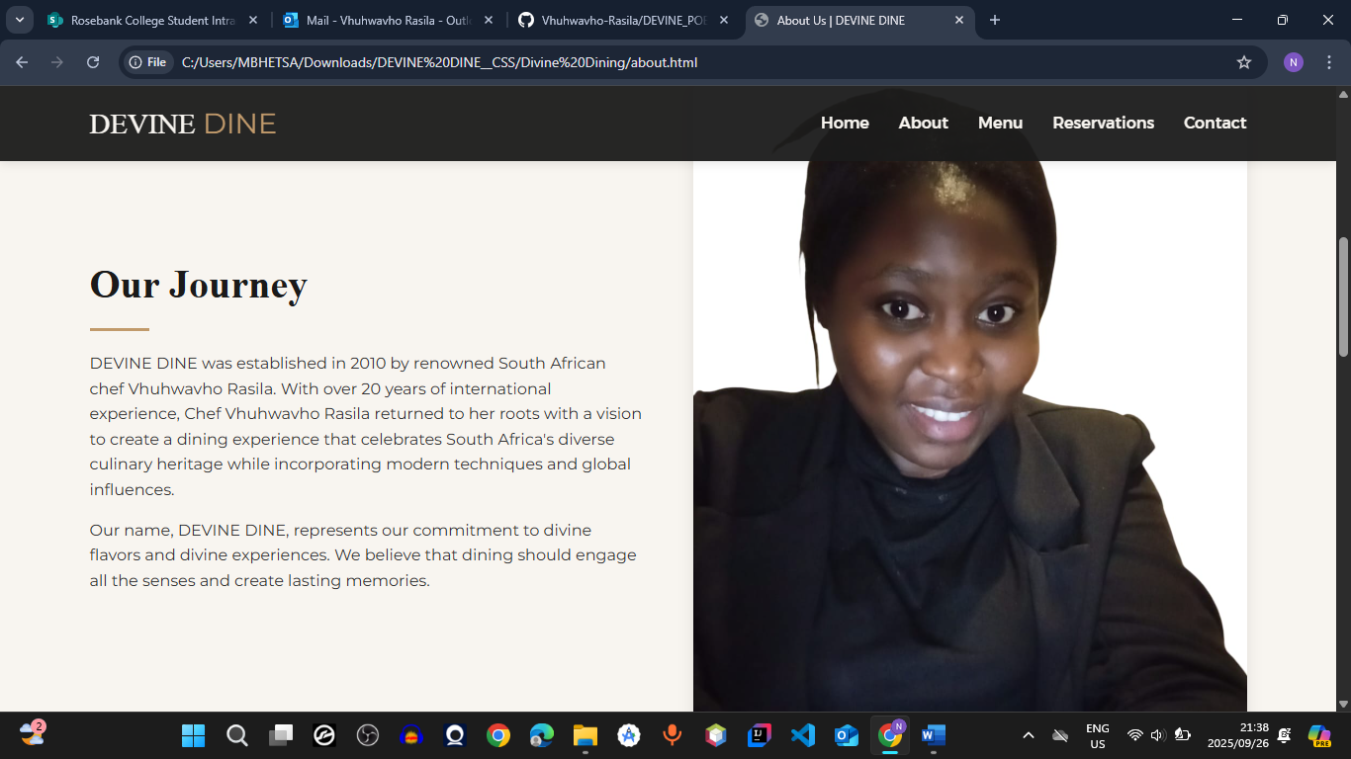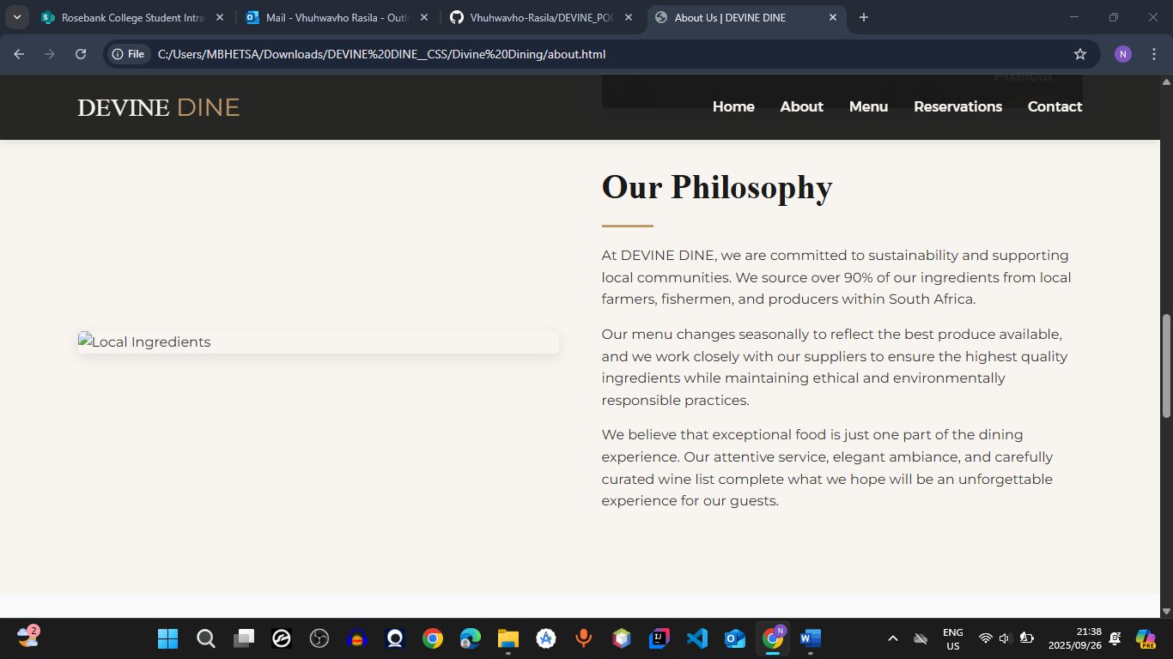

Menu (menu.html)

* This page contains the logo, navigations(hyperlinks) to other pages of the website. It also have buttons where the user can choose what they want to eat and also the price of the food. It contains pictures of the food as well

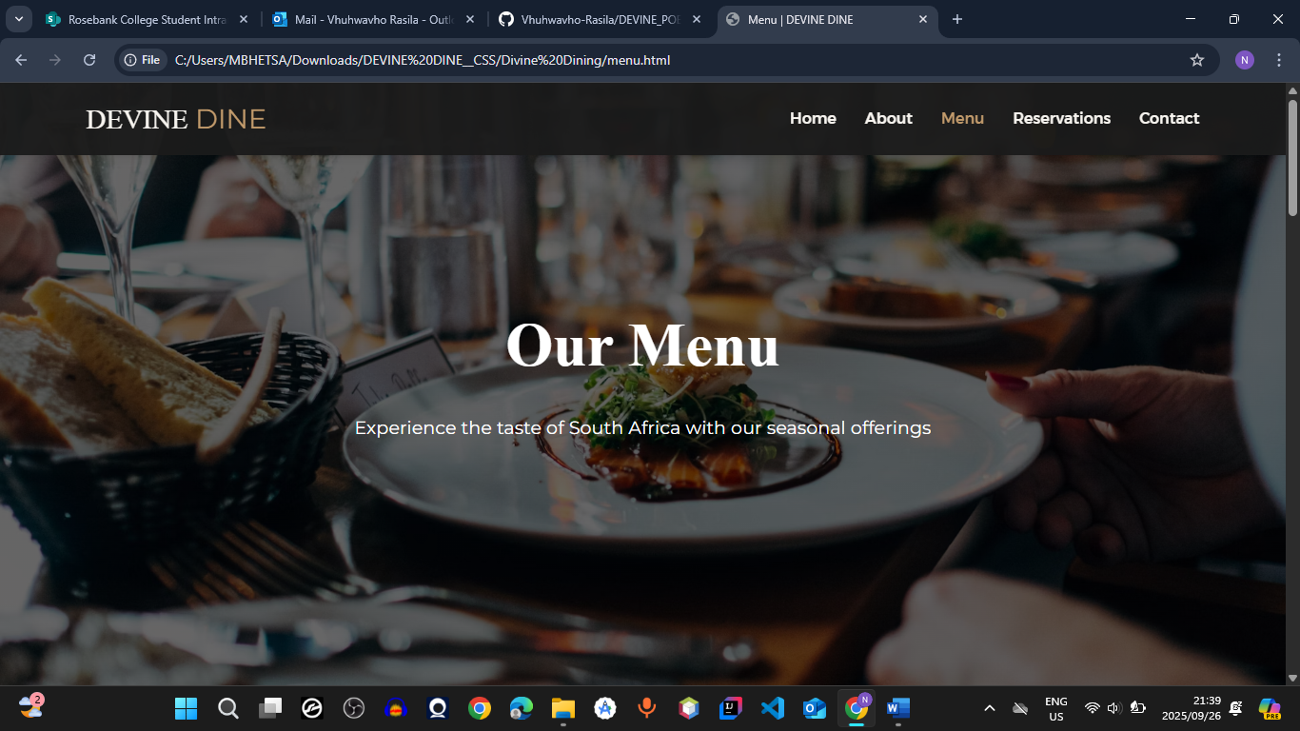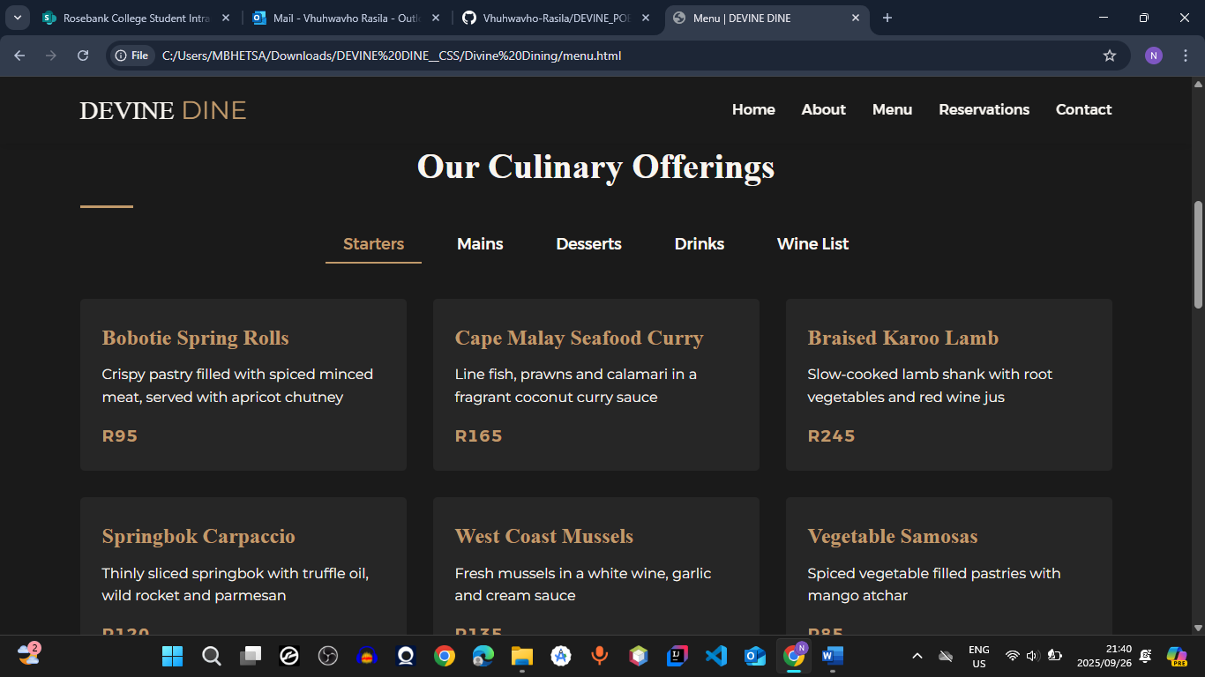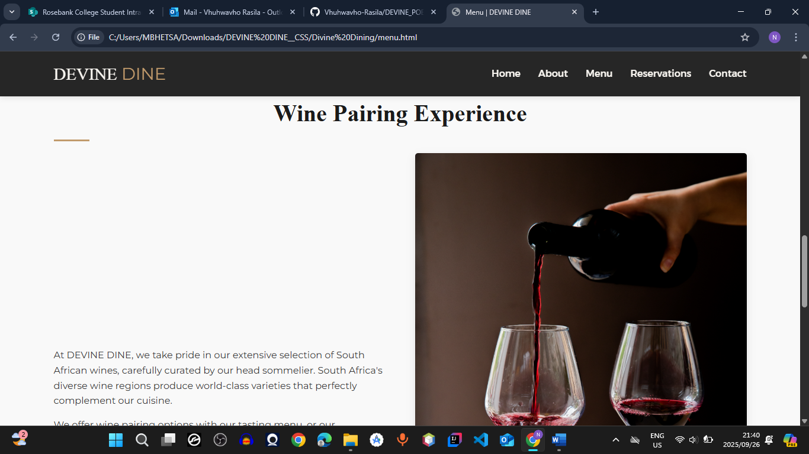

RESERVATIONS (reservations.html)

* This page contains the logo, navigations(hyperlinks) to other pages of the website. This complain a booking for able to book a table prior.

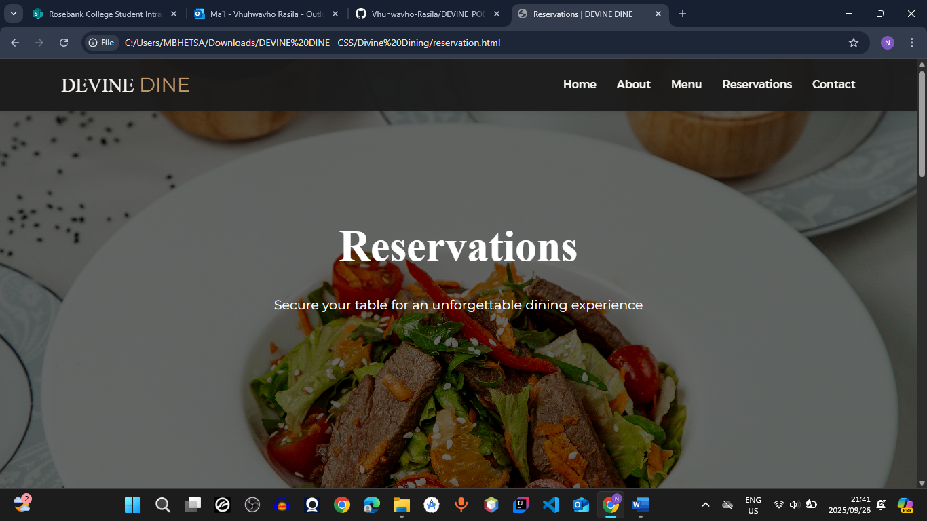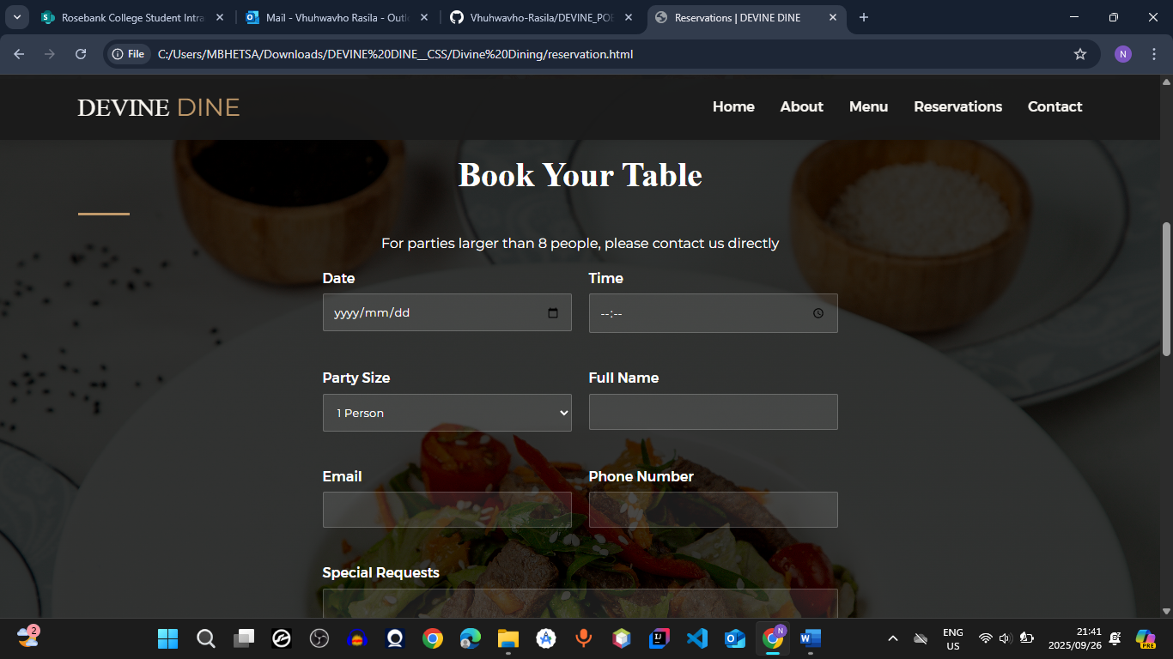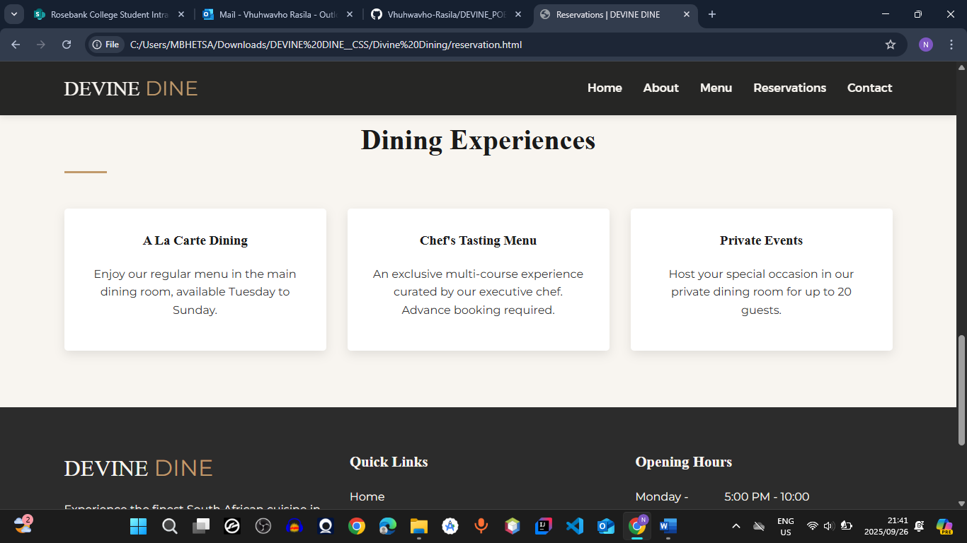

CONTACT (contact.html)

* This page contains the logo, navigations(hyperlinks) to other pages of the website. It has the contact information of the restaurant and also the map which the user can click to get directions

